INTRODUCTION

**1. Introduction**

“An overview of the objective of the Thesis, respective technology and also overview of the company which helped me to perform the tasks related to Thesis.”

The measurement of any physical quantity defines its nature with respect to changes in real world objects and events. For various industrial applications, the flow rate is one of the most important factors and accurate flow measurement therefore is of outmost importance. In all the techniques that measures the flow, the value obtained is an estimated value and accuracy can be determined by comparing with some standard value as reference value. Practically, the accurate flow measurement of any fluid is difficult to obtain and can be achieved using different techniques. Flow measurement using differential pressure transmitter is one among the flow estimation methods, in order to do that many process parameters should be taken into consideration.

Differential pressure flow measurement is one among the most common technologies for measuring the flow in a closed pipe. The pressure difference between the upstream and downstream pressure inside a pipe can be used to determine the flow rate of the fluid. There are many other process parameters affecting the final accuracy of the flow measurement and this document gives you an idea about those parameters. The differential pressure gauges are capable of reducing operational errors, protecting expensive equipment, reduced maintenance costs, etc.

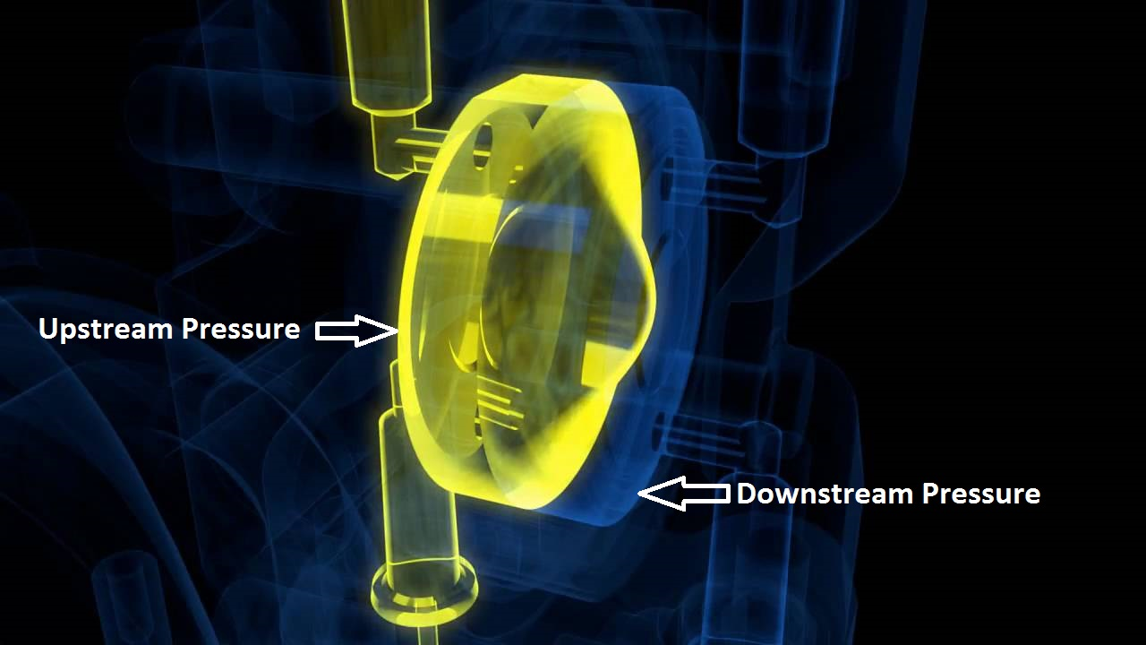

Fig. 1-1: Concept of Differential flow measurement (Source: Endress+Hauser)

This Thesis work is about the analysis of the factors affecting the accuracy of the flow measurement, when using the Endress+Hauser differential pressure transmitters.

**1.1 Company Profile:**

**1.1.1 Organization Structure:**

In 1953, two seemingly different men, one was the Swiss engineer Georg H Endress and the other was the German bank manager Ludwig Hauser, came together to setup a new company named L.Hauser KG. Endress vision and Hauser’s caution proved to be the cornerstones of success. The company first traded under the name Endress + Hauser GmbH in 1957.

Endress+Hauser AG is a Swiss-based leading supplier of products, solutions and services for industrial process automation and process parameters measurement. They offer a comprehensive process solution for flow, level, pressure, temperature, recording and digital communications across a wide range of industries, optimizing processes with regards to economic efficiency, safety, and environmental protection [1]. To serve its customers quickly, flexibly and individually anywhere in the world, they have five production centers with headquarters in Germany and Switzerland which focus on knowhow in research and development, product management as well as logistics. All these production centers also manufacture core components for their worldwide production. Plants in Brazil, China, India and US assemble, test and calibrate instruments mainly for regional markets.

Fig. 1.1 -1: Competence Centers of Endress+Hauser

Endress+Hauser want decisions to be made with expert judgment, where they will make an impact and can be implemented with speed. This is why their subsidiaries in sales and production – the sales centers and production centers – operate as legally independent entities.

**1.1.2 Endress+Hauser GmbH & Co. KG.:**

Endress+Hauser GmbH & Co. KG is headquartered at Maulburg and is usually referred as Product Center Maulburg or PC Maulburg (PCM). It is the competence center for level measurement and level limit detection, Pressure and differential measurement as well as the inventory management solutions. It is one of the leading producers of level and pressure instrumentation. The company employs more than 2000 associates worldwide.

Fig. 1.1 - 2: PC Maulburg and its associated centers

They serve their customers through their sales center and associated product centers. They have their associated product centers in china, India, Brazil and USA. Their measuring instruments find its application in wider branches of industry.

The PC Maulburg consists of many major departments with various sub divisions under each department. The clear explanation of Research and Development department and its sub divisions are explained in detail as shown below with the help of flowchart. The research and development is called with the name “Technology”, which has devices and platform subdivisions. The TD department is related to devices and TP department is related to platform i.e. software.

Fig. 1.1 – 3: PC Maulburg Organization Structure

I have performed my thesis work at Technology and Platform Informatics department which performs tasks on:

* Research and Development
* Software development for a device.
* Development of Platform and driver for a device.
* Maintenance and improvement of software releases.

**1.1.3 Differential Pressure Transmitter:**

Product Center Maulburg is one of the best destinations for pressure instrumentation which includes absolute pressure, relative or gauge pressure and differential pressure. The term multivariable refers to measurement of various parameters at a time. This can be achieved through any differential pressure device, which means that with the help of measured differential pressure other process parameters like flow, density etc., can be estimated or measured. Endress+Hauser GmbH+Co.KG have many differential pressure product portfolios with respect to the field of application, fluid medium etc. By taking all these factors into consideration, the differential pressure devices are divided into classes and the following gives you an overview of various product portfolios under differential pressure instrumentation:

|  |  |  |  |  |
| --- | --- | --- | --- | --- |
| Product Name | Class | Suitable Media | Field of Application | Product |
| Deltabar PMD55 | M | All Liquids | * Flow * Level * Differential Pressure | D:\Users\i00109856\Desktop\Documentation\Thesis Documentation\Screenshots\deltabar M PMD55.jpg |
| Deltabar PMD75 | S | All liquids | * Flow * Level * Differential Pressure | D:\Users\i00109856\Desktop\Documentation\Thesis Documentation\Screenshots\Deltabar_PMD75.jpg |
| Deltabar FMD77 | S | For medias in distillation towers or other vessels with varying temperatures. | * Level * Differential Pressure | D:\Users\i00109856\Desktop\Documentation\Thesis Documentation\Screenshots\DEltabar FMD77.jpg |
| Deltabar FMD78 | S | Insensitive to aggressive, highly viscous, crystallizing or polymerizing media. | * Level * Differential Pressure | D:\Users\i00109856\Desktop\Documentation\Thesis Documentation\Screenshots\Deltabar FMD78.jpg |

In general, based on the optimum price and performance of the device, there are three different pressure instruments offered at PC Maulburg namely

* S- Class: Highest precision, maximum safety, high price, versatile.
* M- Class: Versatile, medium price, Close to highest precision.
* T- Class: Cost-effective, lowest precision, less safety.

Note: The Differential pressure devices are available only in S- Class and M- Class.

**1.2 Thesis Description:**

**1.2.1 Motivation:**

From the customer perspective, multivariable sensors will be the better solution to optimize the costs for the measurement of process parameters. Due to its enormous application in the process industry and vast research scope it has generated great interest for many industries to manufacture such products. With the help of one process parameter, it is difficult to estimate the other parameters accurately.

Differential pressure measurement is widely used in domestic and industrial applications. It is often the basis of other measurements such as flow, level, density, viscosity, and even temperature. The most common being level and flow. By measuring the difference in fluid pressure while the fluid flows through a pipe it is possible to calculate the flow rate. Generally, the performance of any product can be represented in terms of its accuracy, range, uncertainty, etc. A good dp transmitter will ensure that the differential pressure is measured accurately independent of other changing parameters and will reliably transmit a signal to represent the differential pressure. Generally speaking, the primary element is introduced to create a difference in pressure as the flow increases. The primary elements can be of different types such as orifice plate, venturi tube, flow nozzle, pitot tube etc.. The differential pressure developed across the primary element is directly proportional to the flow but the relationship is not linear due to which the performance of the product is deduced. At low flow rates, the uncertainty in dp measurement becomes large making the device less accurate at low flow rate.

However, for future the device performance in terms of flow has to be increased to avoid the customers to spend the money on most expensive flow meters as the less uncertainty is one of the demanding features from the customer perspective.

Currently, the performance of the Endress+Hauser GmbH+Co.KG differential pressure device in terms of flow uncertainty is not up to the expectation. The purpose of my master thesis is identifying the effective parameters and optimizing them to improve the device performance characteristics.

**Document Structure:**

**References:**

1. <http://www.endress.com/en/Endress-Hauser-group>